Home Page

Section-1 (Home page Slider)


Replace with this component

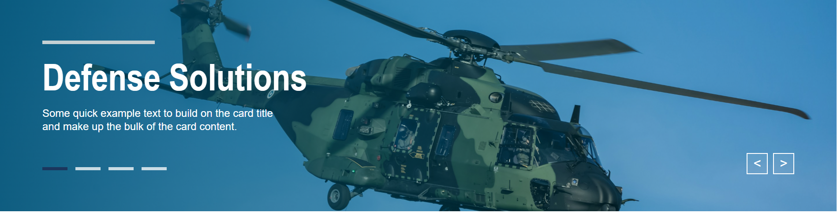

Section-2 (Tab Functionality)
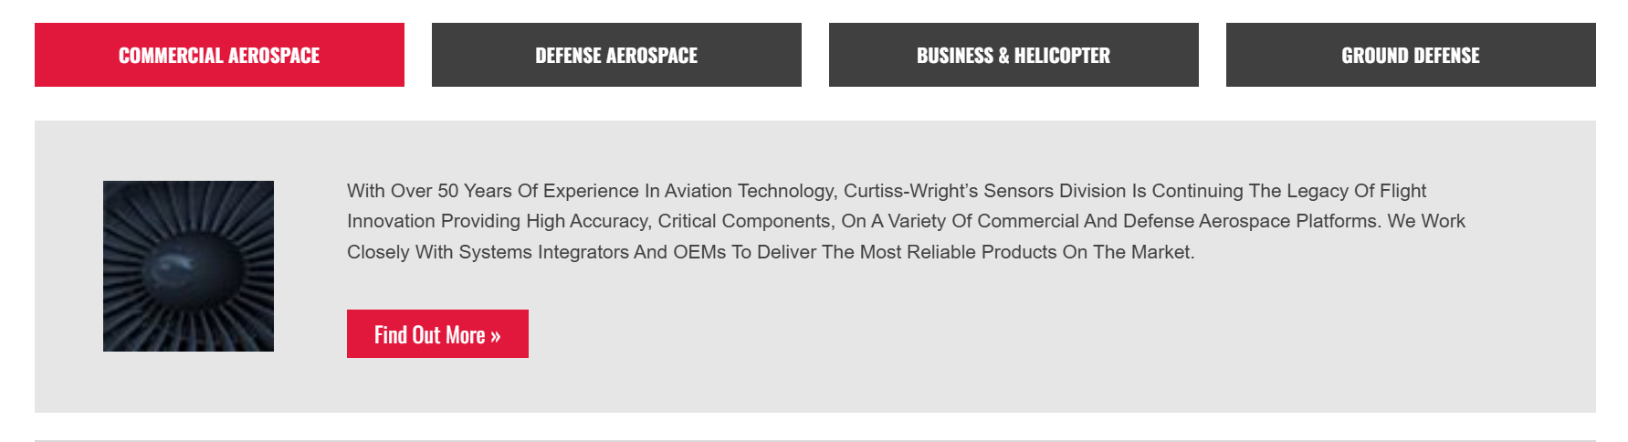

We can merge into add like this one section (Section 1 and Section)

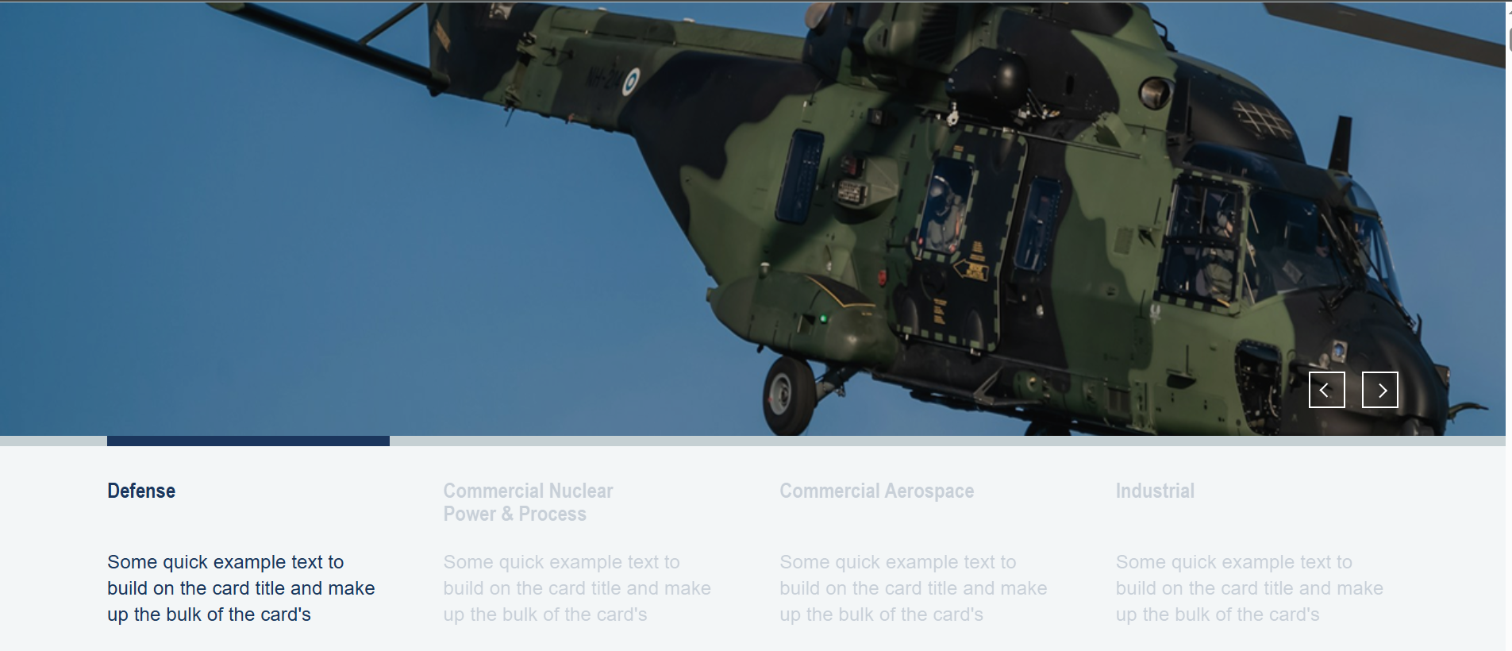

Section-3 (Products)
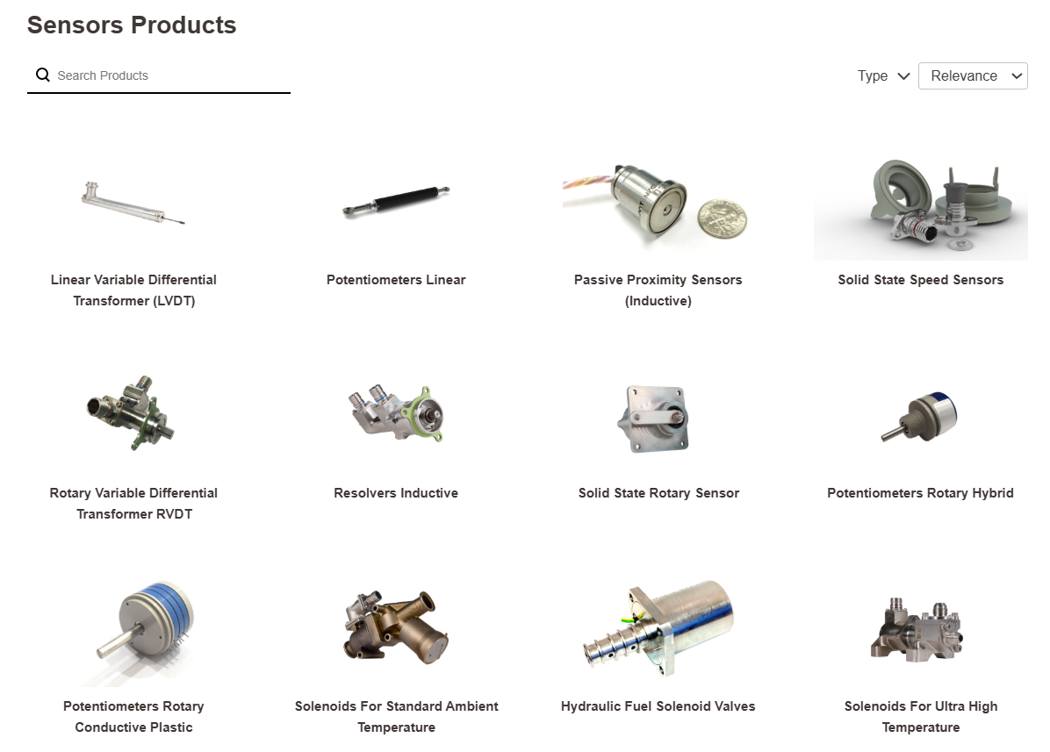

There are no components available for this design. Can we create a new component for it?

Products Page

Products Page : There are no components available for this design. Can we create a new component for it?

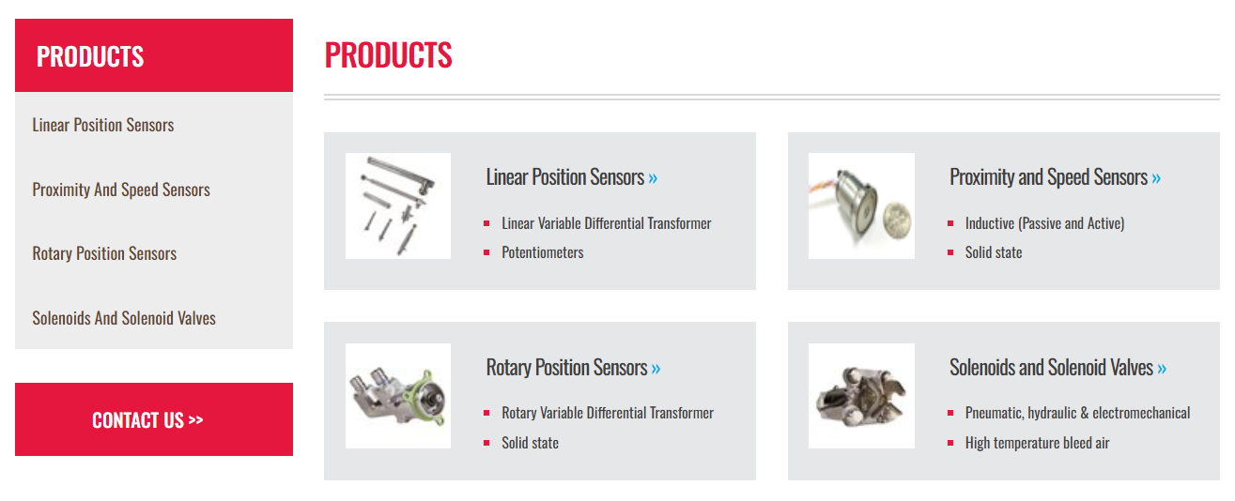

Product Inner Pages

